MUSE-SGI Non-Technical Overview
Transport Sector Module

Context
The transport sector is responsible for about 23% of worldwide CO₂ emissions. As the energy service demand in transport is expected to dramatically increase in the next years, it is of crucial importance to cut the associated emissions in order to meet global decarbonisation targets [1].
In this transition towards a more sustainable mobility, new technologies will play a major role and will imply novel fuel portfolios. Hydrogen, electricity and biofuels have often been acknowledged as instrumental to this change. However, the deployment of these fuels and of the associated technologies may only be feasible if careful R&D plans and technology development strategies are in place. It is also noteworthy that revolutionary technologies deployment will have social effects on the traffic volume and modal split.

Problem Statement
The transport sector module, TSM, has to determine the energy service demand for transport and explore how this demand will be met in terms of modal split, technology and fuel mix on a global scale. This must be realized involving, on the one hand, the key macrodrivers to the energy service demand, and, on the other hand, representing realistic market players’ behaviour towards technological change. The TSM needs to be technology-rich as well as appropriately informed with the macrodrivers which best represent the trend of traffic volume in every modelled region. It must apply a bottom-up approach to model each transport technology to describe the associated impact on energy use and greenhouse gases emissions.

Module Approach
The transport sector module in MUSE, the TSM, is a simulation model with the ultimate goal to produce a timeseries of fuel demand to meet the projected energy service demand. It responds to a timeseries of macroeconomic drivers, such as GDP, as well as fuel and carbon prices on a global scale using the regional disaggregation of the world into the 28 regions of MUSE.
The module works on a two-step approach. First, the energy service demand is dynamically calculated using macrodrivers and price elasticity. Then the TSM applies a merit order approach to define the technology market share, and, consequently, the fuel mix.
In order to represent plausible transport futures and the effects of policy and technological changes, the TSM applies a bottom-up approach to the technology characterization, based on unit technology cost, efficiencies, lifetime as well as emissions. In addition to the fuel demand, the TSM also produces techno-economic (CAPEX, OPEX) as well as environmental performance (greenhouse gas emissions) indicators for all the transport technologies, per region, simulated period and timeslice.

Relationship with MUSE Modules
The main information workflow between the TSM and the core MUSE algorithm, the Market Clearing Algorithm (MCA), is shown for a generic iteration in a generic region, time period and timeslice in Figure 1. The module also uploads exogenous parameters to project the energy service demand (macrodrivers) and to populate the techno-economic and environmental characteristics of the technologies per region.
The detailed description of the data exchange protocol between TSM and MUSE is also in Table 1.

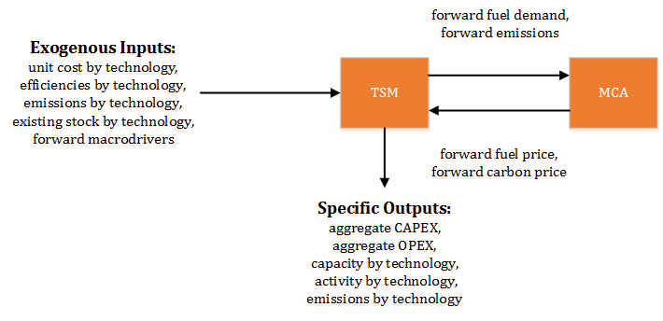
Figure 1: Major interactions between TSM and the rest of MUSE

Table 1: Description of the data exchange protocol for the TSM.
TSM Key Inputs | TSM Key Outputs
MUSE core dynamic variables  - Forward fuel price for each time period, region and timeslice (MUSD₂₀₁₀/PJ)  - Forward carbon price (MUSD₂₀₁₀/GtCO₂)  TSM-specific input parameters  - Techno-economic characterisation (conversion efficiency, unit investment and operating costs) of each transport technology by type in each time period and region  - Existing stock for the model base year by technology type, including their retirement profile  - Forward macrodriver projection | MUSE core dynamic variables  - Forward fuel demand for each region with timeslice disaggregation (PJ/year)  - Forward emissions for each time period, region and timeslice (GtCO₂/year)  TSM-specific outputs  - Investment and retirement in capacity terms in the transport sector by time period, technology type and region  - Aggregate CAPEX and OPEX by time period, timeslice and region  - Transport technologies details (e.g. activity, energy consumption and emissions) by time slice, technology type and region

References
- Transport, energy and CO₂. Moving toward sustainability. International Energy Agency, 2009.

