Template Protocol for CTIMPs

<Study Acronym>

<Full study title>

<Version number and date>

MAIN SPONSOR or co-sponsors: Imperial College London/Imperial College Healthcare NHS Trust (delete as applicable)
FUNDERS: xxx
STUDY COORDINATION CENTRE: xxx

IRAS Project ID: xxx
REC reference: xxx
EudraCT reference: xxx

Protocol authorised by:

Name & Role | Date | Signature

Study Management Group

Chief Investigator:

Co-investigators:

Statistician:

Trial Management:

Study Coordination Centre

For general queries, supply of trial documentation, and collection of data, please contact:

Study Coordinator:
Address: Randomisations:
Tel: E-mail:
Fax: Web address:

Clinical Queries

Clinical queries should be directed to xxx who will direct the query to the appropriate person

Sponsor

Imperial College London/Imperial College Healthcare NHS Trust (delete as applicable)
is the main research Sponsor for this study. For further information regarding the sponsorship conditions, please contact the Head of Regulatory Compliance at:

Research Governance and Integrity Team (RGIT)
Imperial College London and Imperial College Healthcare NHS Trust
Room 215, Level 2, Medical School Building
Norfolk Place
London, W2 1PG
Tel: 0207 594 9480
Imperial College - Research Governance and Integrity Team (RGIT) Website

Funder

[Who is funding the study]

This protocol describes the xxx study and provides information about procedures for entering participants. The protocol should not be used as a guide for the treatment of other participants; every care was taken in its drafting, but corrections or amendments may be necessary. These will be circulated to investigators in the study, but centres entering participants for the first time are advised to contact the trials centre to confirm they have the most recent version.
Problems relating to this trial should be referred, in the first instance, to the study coordination centre.
This trial will adhere to the principles outlined in the Medicines for Human Use (Clinical Trials) Regulations 2004 (SI 2004/1031), amended regulations (SI 2006/1928) and the International Conference on Harmonisation Good Clinical Practice (ICH GCP) guidelines. It will be conducted in compliance with the protocol, the Data Protection Act and other regulatory requirements as appropriate.

Table of Contents Page No
1. INTRODUCTION
1.1 BACKGROUND
2. STUDY OBJECTIVES
3. STUDY DESIGN
3.1 Study outcome measures
4. Participant Entry
4.1 Pre-randomisation evaluations
4.2 Inclusion Criteria
4.3 EXCLUSION CRITERIA
4.4 WithdrawAl criteria 13
5. RANDOMISATION AND ENROLMENT PROCEDURE
5.1 rANDOMISATION OR REGISTRATION PRACTICALITIES
5.2 UNBLINDING
6. TREATMENTS
6.1 Treatment arms
6.2 DOSE MODIFICATIONS FOR TOXICITY
6.3 PREMEDICATION
6.4 Interaction with other drugs
6.5 dispensing and accountability
7. Pharmacovigilance
7.1 Definitions
7.2 Causality
7.3 Reporting Procedures
8. ASSESSMENT AND FOLLOW-UP
8.1 loss to follow-up
8.2 trial closure
9. STATISTICs and data analysis
10. monitoring
10.1 Risk assessment
10.2 monitoring at study coordination centre
10.3 monitoring at local site
11. regulatory issues
11.1 CTA
11.2 Ethics approval
11.3 Consent
11.4 Confidentiality
11.5 Indemnity
11.6 Sponsor
11.7 Funding
11.8 Audits and Inspections
12. Trial Management
13. Publication Policy
14. References
EXAMPLE APPENDICES
Appendix 1. Example List of Expected toxicities
Appendix 2. Summary of investigations, treatment and assessments

Glossary of Abbreviations

Keywords
[Insert a list of keywords]

Study Summary

TITLE
DESIGN
AIMS
OUTCOME MEASURES
POPULATION
ELIGIBILITY
TREATMENT
duration

Reference diagram
 | RANDOMISE
ARM A |  | ARM B

1. INTRODUCTION

1.1 BACKGROUND
[To include: review of previous studies, disease particulars, incidence, current treatment options, risks and benefits]

1.2 RATIONALE FOR CURRENT STUDY
[To include: research question and hypothesis, as well as potential risks and benefits]

2. STUDY OBJECTIVES

[List the primary, secondary and other study objectives]

3. STUDY DESIGN

[Type of study: eg randomised double-blind placebo controlled etc.]
[Duration: ie what constitutes the treatment phase and the follow-up phase of the study]
[Number and type of subjects to be recruited: eg 800 participants, 400 of which healthy]

3.1 Study outcome measures
What are the endpoints of the study?[eg: disease-free survival, toxicity etc]. List the primary and secondary outcomes measures.

Table of Objectives and outcome measures
Objectives | Outcome Measures | Timepoint(s) of evaluation of this outcome measure (if applicable)
Primary Objective  Example: To compare the effect of treatment A versus treatment B on the levels of protein X in the blood | Describe the outcome measures and how/when they will be measured during the trial.  Outcome measures should reflect the objectives. It is important that only one outcome measure is selected as it will be used to decide the overall results or ‘success’ of the trial. The primary outcome measure should be measurable, clinically relevant to participants and widely accepted by the scientific and medical community.  Assessments of outcome measures should be described in detail in section 7  Example: Concentration of protein X in blood samples from participants on each treatment | Example: Blood sampling at day 0 and day 28 post-treatment
Secondary Objectives  Example: To assess the safety of treatment A in <insert condition/population> | As above
Tertiary Objectives  Please add if applicable, otherwise delete this row | As Above

4. Participant Entry

4.1 Pre-randomisation evaluations
[What tests need to be included before a participant can enter the study? Eg, FBC, LFT, biopsy, CT scan. All screening procedures should be included]

4.2 Inclusion Criteria
[Include justifications, if necessary]

4.3 EXCLUSION CRITERIA
[Include justifications, if necessary]

4.4 WithdrawAl criteria
[Describe procedures for stopping early]
[Describe proceduresfor participants should they wish to withdraw their consent, ie will all data to date be held, will all date be destroyed]

5. RANDOMISATION AND ENROLMENT PROCEDURE

5.1 rANDOMISATION OR REGISTRATION PRACTICALITIES
[Describe procedures enrolling participants and what needs to be completed prior to randomisation. Give numbers to ring for randomisation]

5.2 UNBLINDING
[unblinding is discouraged during the study unless required to by urgent safety measures. Give details on how this will be done (if applicable). Please see safety reporting SOP for further details]

6. TREATMENTS

6.1 Treatment arms
[Mention dosage, route of administration, labelling, packaging, where study drugs will come from, whether a supply will be delivered to pharmacy at randomisation/registration, if study drug is free.]

6.2 DOSE MODIFICATIONS FOR TOXICITY
[Tables are especially useful to demonstrate what dose reductions should be taken in the event of toxicity]

6.3 PREMEDICATION
[Drugs should be listed if they are to be prescribed before or during trial treatment, eg antibiotics]

6.4 Interaction with other drugs
[Are there any medications that the participant should avoid?]

6.5 dispensing and accountability
[Procedures for pharmacy]

7. Pharmacovigilance

7.1 Definitions
Adverse Event (AE): any untoward medical occurrence in a patient or clinical trial subject administered a medicinal product and which does not necessarily have a causal relationship with this treatment. An AE can therefore be any unfavourable and unintended sign (including an abnormal laboratory finding), symptom, or disease temporally associated with the use of an investigational medicinal product (IMP), whether or not considered related to the IMP.

Adverse Reaction (AR): all untoward and unintended responses to an IMP related to any dose administered. All AEs judged by either the reporting investigator or the sponsor as having reasonable causal relationship to a medicinal product qualify as adverse reactions. The expression reasonable causal relationship means to convey in general that there is evidence or argument to suggest a causal relationship.

Unexpected Adverse Reaction: an AR, the nature or severity of which is not listed in the reference safety information (RSI) e.g. list of expected medical events within investigator’s brochure for an unapproved investigational product or section 4.8 of the summary of product characteristics (SmPC) for an authorised product. When the outcome occurs this adverse reaction should be considered as unexpected. Side effects documented in the SmPC which occur in a more severe form than anticipated are also considered to be unexpected.

Serious Adverse Event (SAE) or Serious Adverse Reaction: any untoward medical occurrence or effect that at any dose:
- Results in death.
- Is life-threatening – refers to an event in which the subject was at risk of death at the time of the event; it does not refer to an event which hypothetically might have caused death if it were more severe.
- Requires hospitalisation, or prolongation of existing inpatients’ hospitalisation.
- Results in persistent or significant disability or incapacity.
- Is a congenital anomaly or birth defect.

Medical judgement should be exercised in deciding whether an AE/AR is serious in other situations. Important AE/ARs that are not immediately life-threatening or do not result in death or hospitalisation but may jeopardise the subject or may require intervention to prevent one of the other outcomes listed in the definition above, should also be considered serious.

Suspected Unexpected Serious Adverse Reaction (SUSAR): any suspected adverse reaction related to an IMP that is both unexpected and serious.

7.2 Causality
Most adverse events and adverse drug reactions that occur in this study, whether they are serious or not, will be expected treatment-related toxicities due to the drugs used in this study. The assignment of the causality should be made by the investigator responsible for the care of the participant using the definitions in the table below.

If any doubt about the causality exists the local investigator should inform the study coordination centre who will notify the Chief Investigators. The pharmaceutical companies and/or other clinicians may be asked to advise in some cases.

In the case of discrepant views on causality between the investigator and others, all parties will discuss the case. In the event that no agreement is made, the MHRA will be informed of both points of view.

Relationship | Description
Unrelated | There is no evidence of any causal relationship
Unlikely | There is little evidence to suggest there is a causal relationship (e.g. the event did not occur within a reasonable time after administration of the trial medication). There is another reasonable explanation for the event (e.g. the participant’s clinical condition, other concomitant treatment).
Possible | There is some evidence to suggest a causal relationship (e.g. because the event occurs within a reasonable time after administration of the trial medication). However, the influence of other factors may have contributed to the event (e.g. the participant’s clinical condition, other concomitant treatments).
Probable | There is evidence to suggest a causal relationship and the influence of other factors is unlikely.
Definitely | There is clear evidence to suggest a causal relationship and other possible contributing factors can be ruled out.
Not assessable | There is insufficient or incomplete evidence to make a clinical judgement of the causal relationship.

7.3 Reporting Procedures
All adverse events should be reported. Depending on the nature of the event the reporting procedures below should be followed. Any questions concerning adverse event reporting should be directed to the study coordination centre in the first instance. A flowchart is given below to aid in the reporting procedures.

7.3.1 Non serious AR/AEs
All such toxicities, whether expected or not, should be recorded in the toxicity section of the relevant case report form and sent to the study coordination centre within one month of the form being due.

7.3.2 Serious AR/AEs
Fatal or life threatening SAEs and SUSARs should be reported on the day that the local site is aware of the event. The SAE form asks for nature of event, date of onset, severity, corrective therapies given, outcome and causality (i.e. unrelated, unlikely, possible, probably, definitely). The responsible investigator should sign the causality of the event. Additional information should be sent within 5 days if the reaction has not resolved at the time of reporting.

SAEs
An SAE form should be completed and faxed to the study coordination centre for all SAEs within 24 hours. However, relapse and death due to <condition>, and hospitalisations for elective treatment of a pre-existing condition do not need reporting as SAEs.

SUSARs
In the case of suspected unexpected serious adverse reactions, the staff at the site should:

Complete the SAE case report form & send it immediately (within 24 hours,), signed and dated to the study coordination centre together with relevant treatment forms and anonymised copies of all relevant investigations.
Or
Contact the study coordination centre by phone and then send the completed SAE form to the study coordination centre within the following 24 hours as above.

The study coordination centre will notify the MHRA, REC and the Sponsor of all SUSARs occurring during the study according to the following timelines; fatal and life-threatening within 7 days of notification and non-life threatening within 15 days. All investigators will be informed of all SUSARs occurring throughout the study.

Local investigators should report any SUSARs and /or SAEs as required by their Local Research Ethics Committee and/or Research & Development Office.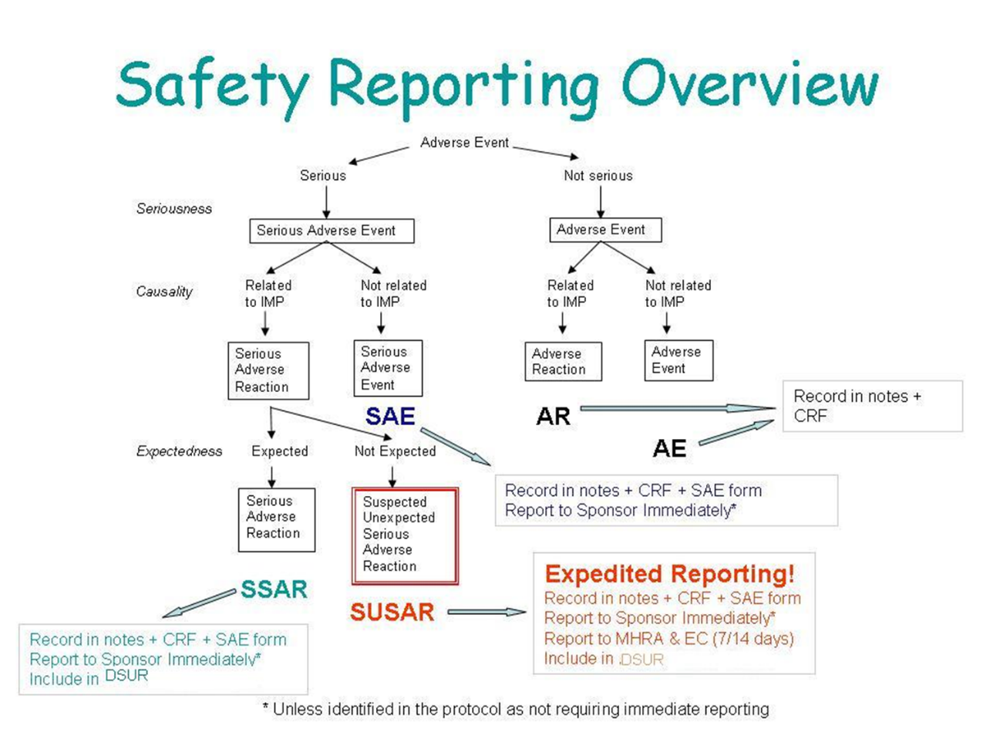

Contact details for reporting SAEs and SUSARs
RGIT.ctimp.team@imperial.ac.uk
CI email (and further details below).
Fax: xxx, attention xxx
Please send SAE forms to: xxx
Tel: xxx (Mon to Fri 09.00 – 17.00)

8. ASSESSMENT AND FOLLOW-UP

[How long will the participant be followed up for? When and what will their assessments consist of? Efficacy assessments should also be included]

Incidental findings
Describe how incidental findings will be identified, reviewed and reported, and to which individuals they will be reported to (i.e. GP, clinical care team).

loss to follow-up
[list procedures for participants lost to f/up, eg if flagging through ONS ]

trial closure
[list procedures for closing a trial, whether early or after end of recruitment. ]
[Definition of end of trial]

9. Statistics and Data analysis

[Statistical plan, eg sample size calculation and data analysis, methods of randomisation.]

[Describe interim analyses, if planned]

Data and all appropriate documentation will be stored for a minimum of 10 years (5 years if ICHT sponsored study) after the completion of the study, including the follow-up period.

Monitoring

Risk assessment
[Describe the risk assessment that has taken place for the study. Is the study considered high, medium or low risk? How does this justify level of monitoring provided?]

monitoring at study coordination centre
[EG data entry checks, double data entry, consent form checks, missing or unusual data values]

monitoring at local site
[based on risk assessment, how many site visits, what level of source data verification]

Regulatory Issues

11.1 CTA
This study has Clinical Trials Authorisation from the UK Competent Authority; MHRA. Reference: xxx

[this will change if the study is conducted overseas, include other competent authorities as required]

11.2 Ethics approval
The Study Coordination Centre has obtained approval from the xxx Research Ethics Committee (REC) and Health Research Authority (HRA). The study must also receive confirmation of capacity and capability from each participating NHS Trust before accepting participants into the study or any research activity is carried out. The study will be conducted in accordance with the recommendations for physicians involved in research on human subjects adopted by the 18th World Medical Assembly, Helsinki 1964 and later revisions.

11.3 Consent
Consent to enter the study must be sought from each participant only after a full explanation has been given, an information leaflet offered and time allowed for consideration. Signed participant consent should be obtained. The right of the participant to refuse to participate without giving reasons must be respected. After the participant has entered the trial the clinician remains free to give alternative treatment to that specified in the protocol at any stage if he/she feels it is in the participant’s best interest, but the reasons for doing so should be recorded. In these cases the participants remain within the study for the purposes of follow-up and data analysis. All participants are free to withdraw at any time from the protocol treatment without giving reasons and without prejudicing further treatment.

11.4 Confidentiality
Pseudonymised data is data that can be linked back to a person (e.g. coded data). It is considered both personal and identifiable data. Anonymised data is data that has no code and cannot be linked back to a person (e.g. aggregated data for publication, data without a code that cannot be linked back to a person)

The Chief Investigator will preserve the confidentiality of participants taking part in the study and is registered under the Data Protection Act.

Data will be anonymised/pseudonymised (delete as applicable)

Data will be transferred to (insert third party name as appropriate or delete)

11.5 Indemnity
Imperial College London holds negligent harm and non-negligent harm insurance policies which apply to this study/ Imperial College Healthcare NHS Trust holds standard NHS Hospital Indemnity and insurance cover with NHS resolution for NHS Trusts in England, which apply to this study (delete as applicable)

11.6 Sponsor
Imperial College London/Imperial College Healthcare NHS Trust (delete as applicable) will act as the main Sponsor for this study. Delegated responsibilities will be assigned to the NHS trusts taking part in this study.

11.7 Funding
xxx are funding this study. [Any per patient payments, investigator payments should be detailed here]

11.8 Audits and Inspections
The study may be subject to inspection and audit by Imperial College London/Imperial College Healthcare NHS Trust (delete as applicable) under their remit as Sponsor, the Study Coordination Centre and other regulatory bodies to ensure adherence to GCP.

12. Trial Management

A Trial Management Group (TMG) will be appointed and will be responsible for overseeing the progress of the trial. The day-to-day management of the trial will be co-ordinated through the xxx Study Coordination Centre.
[Describe whether a Trial Steering Committee or Data Monitoring Committee will be convened]

(delete once inserted) CI to include study specific reporting requirements/notification responsibilities for the study

13. Publication Policy

The study's publication policy should be described in full. Below is an example paragraph.
All publications and presentations relating to the study will be authorised by the Trial Management Group. The first publication of the trial results will be in the name of the Trial Management Group, if this does not conflict with the journal’s policy. If there are named authors, these will include at least the trial’s Chief Investigator, Statistician and Trial Coordinator. Members of the TMG and the Data Monitoring Committee will be listed and contributors will be cited by name if published in a journal where this does not conflict with the journal’s policy. Authorship of parallel studies initiated outside of the Trial Management Group will be according to the individuals involved in the project but must acknowledge the contribution of the Trial Management Group and the Study Coordination Centre.

14. References
[List of useful and relevant references for the study]

EXAMPLE APPENDICES
Appendices should be additional information to the protocol and can consist of:
- Common Terminology Criteria for Adverse Events (NCI CTC).
- RECIST criteria.
- WHO / ECOG Performance status.
- Drug information from SmPC.
- PIS, Consent form, GP letter (although may be more practical to have them separate).
- Summary of dose modifications.
- Expected side effects.
- Schedule of events table.

Appendix 1. Example List of Expected toxicities

Toxicity | Drug A | Drug B
Haematopoeitic:
Anaemia
Leukopenia
Neutropenia
Thrombocytopenia
Gastrointestinal:
Abdominal pain
Constipation
Diarrhoea

Appendix 2. Summary of investigations, treatment and assessments

Exam
 | Pre-treatment | 1 | 2 | 3 | 4 | 5 | 6
MRI | X |  |  | X |  |  | X
Chest x-ray | X
History, physical exam | X
ECG | X |  |  |  |  | X
WHO performance status | X
FBC, U&E, LFT | X | X | X | X | X | X | X
Informed consent | X

